Survey for Green Chemistry Summer School Attendees
United Nations Environment Programme and IUPAC/ICGCSD

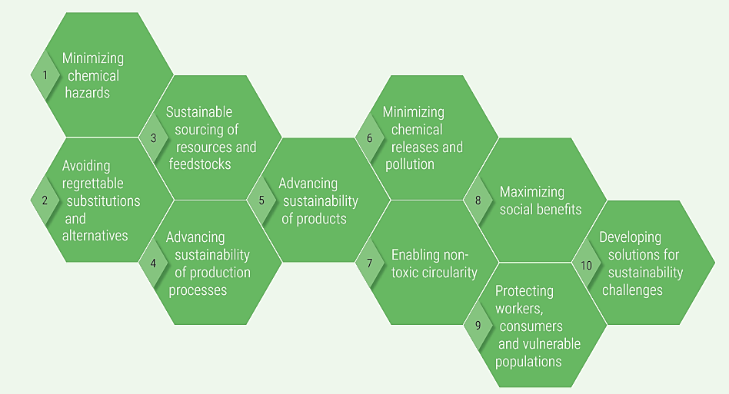
This survey is meant to inform the work being done by the United Nations Environment Programme (UNEP) on green and sustainable chemistry. UNEP has already published a comprehensive report outlining called the Green and Sustainable Chemistry: Framework Manual. The manual introduces, in a structured way, various facets of green and sustainable chemistry, with the intention to foster general learning, reflection and scaling- up action.

The centerpiece of the report are the 10 objectives and guiding considerations for green and sustainable chemistry. Agreed upon by a group of chemistry experts in government, academia and industry, they range from molecular design considerations to addressing societal inequalities. They are meant to provide a reference point for all stakeholders that utilize chemistry as well as those which influence the way it is practiced. UNEP is working to promote the recognition and adoption of the 10 objectives and guiding considerations such that users of chemistry adhere to them and contribute to fulfilling their criteria.

The information gathered from this survey will aid UNEP in assessing the current green and sustainable chemistry landscape around the world and to help them understand the journey you have taken to end up as an invitee to one of world's premier green chemistry events.
They will be useful to the Interdivisional Committee on Green Chemistry for Sustainable Development of IUPAC , ICGCSD, and all IUPAC Divisions and Committees for the educational and outreach activities.
Thank you in advance for taking the time to fill out the survey, we are looking forward to the event and to learning from your responses.

Demographic Questions

Name: ___________________________________________________________

Age Group: 18-25 ___ 26-34 ___ 35-42___ 43 – 54 ___ 55+ ___

Country of Origin: ___________________________________

Current Country of Residence: ______________________________

Current Institution/University: __________________________________

Position or Title: _____________________________________

Field of Study: ________________________________________

Questions:
- When and where were you first introduced to green chemistry or green and sustainable chemistry? Please mark the box and explain.
( ) – In the classroom
( ) – In the workplace
( ) – In the home or community (i.e. The News, Browsing the Internet, Talking with a friend or family member)

Please explain:

- Has learning about sustainability (environmental, social or economic) and/or environmental issues been emphasized during your education? Please mark the box and provide an example.
( ) – Yes it has been emphasized
( ) – No it has not been emphasized

Please explain and provide an example of how sustainability was included in your education:

- Can you provide an example/s of when you were exposed to a green and sustainable chemistry concept in the classroom? Please mark the box and explain.
( ) – Green and sustainable Chemistry was mentioned in the classroom
( ) – Green and Sustainable Chemistry was never mentioned in the classroom

Please explain:

- Can you provide an example of an action being taken in your community (country, community, workplace) to advance green and sustainable chemistry? Please mark the category of action and explain below.
( ) – Use of a Green and Sustainable Chemistry Technology / Innovation
( ) – Research and Development Activity
( ) – Education or Learning Initiative
( ) – Government Regulation (i.e. banning a certain chemical, sustainable procurement guidelines)
( ) – Innovation promoting policies and initatives (Government investments in research, Green Chemistry Awards, Enabling policies)
( ) – Market Based Instrument (i.e. tax credit, green bonds)

Please explain the action:

- What do you consider to be one important action to raise awareness and increase the impact of green and sustainable chemistry?

